**Pew Pew: AdMob Guide**

This guide otulines how to display banner and interstitial ads served by Admob. Requires admob account, details can be found here: <https://www.google.com/admob>

**Setup ID’s**

Once you have an account and setup an application within the admob dashboard, you will need to add your advertisement ID’s to Pew Pew.

1. Open AdMob_IDs.cs, located in Pew Pew/Scripts/Ads.
2. Edit the public strings, shown in the image below. You are provided with these ids when you setup the application in the link provided at the beginning of this guide.

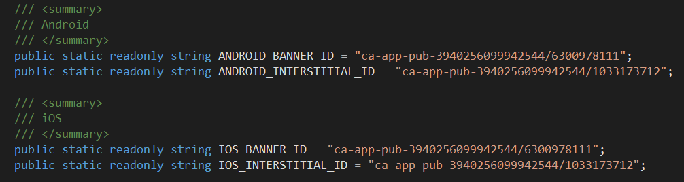

The ids provided are test ids. You will need to provide your own.

**Banner ads**

Banner ads can be shown on the main menu scene and/or the game scene. To change visibility:

1. Open the Main Menu scene. Located in Pew Pew/Scenes.
2. Find the Banner AD_Persistent GameObject in the hierarchy.
3. From here you can toggle whether banner ads are displayed in the game screen and/or the main menu scene.

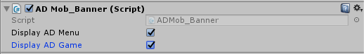

You can turn off banner ads completely by un-selecting both of these options.

**Interstitial ads**

Interstitial ads can be shown when:

* A round is complete
* The player dies
* The game is over

You can also change how many rounds need to be complete and player deaths are required before showing an ad.

1. Open the Game scene. Located in Pew Pew/Scenes.
2. Find the Interstitial GameObject in the hierarchy.
3. From here you can toggle if and how often interstitial ads are shown. For example, if you set ‘Num Of Rounds Required’ to 5, an interstitial ad will be shown every 5 rounds.

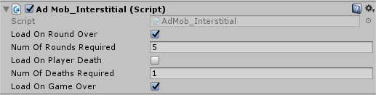

It is recommended not to have these numbers too low as the player will get fed up if they are shown too many ads.

You can turn off interstitial ads completely by un-selecting these three options.